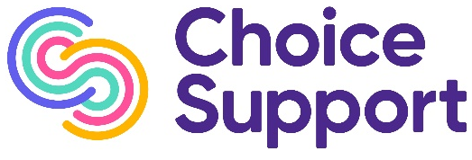

JOB VACANCY

Community Engagement Officer

Public Engagement Network

(37.5 hours per week, worked over 5 days)

Home based with travel in the South of England region

Salary: £23,758.40 per annum plus attendance bonus

We are looking for an additional Community Engagement Officer to join our team.

Do you live in the South region of England?
(see the locations and map at the end of this advert)

Do you have a range of excellent communication skills?

Do you have the skills and experience of engaging with a diverse group of individuals, organisations and groups who represent seldom heard communities?

Are you able to provide outstanding customer care and represent Choice Support in a positive and professional manner to both internal and external agencies?

Are you able to be home based and have the ability to travel to different locations in the South of England?

Do you want to develop your skills, knowledge and experience of inclusion and diversity and work closely with our Care Quality Commission colleagues?

Then this is the role you’ve been looking for!

In return, we are offering a competitive annual salary, 25 days annual leave plus bank holidays, life assurance and discounted shopping vouchers.

If you would like more information, and an informal discussion about the position, please contact Emma Clements on emma.clements@choicesupport.org.uk T: 07554 453 250

To apply, please download an application pack from our website and send your completed application to exesensitiveinfo@choicesupport.org.uk

This advert will be open until the vacancy is filled.

We are committed to promoting diversity and inclusion and taking action to address inequality. We particularly welcome applications from anyone who is from a Black, Asian or minority ethnic background, anyone who considers themselves to have a disability and members of the LGBTQ+ community.

Choice Support is Disability Confident which is a scheme run by the Department of Work and Pensions. As part of our commitment, we operate a Guaranteed Interview Scheme - all candidates who declare a disability and meet the essential criteria for the role will be guaranteed an interview.

Areas covered within the South of England based on Integrated Care System regions are;-
- Bath and North East Somerset, Swindon and Wiltshire
- Bristol, North Somerset and South Gloucestershire
- Buckinghamshire, Oxfordshire and Berkshire West
- Cornwall and the Isles of Scilly
- Devon
- Dorset
- Frimley Health and Care
- Gloucestershire
- Hampshire and the Isle of Wight
- Kent and Medway
- Somerset
- Surrey Heartlands
- Sussex

